2022

NourhenLtf

GoMyCode

16/02/2022

Web fundamentals project



Introduction

Web Work is a network of things linked together in a way that resembles a web. Other definition of web work is work performed using the World Wide Web

* How does the web work?
* What do you need to be a web developer?
* What is the role of a web developer?

1. The web browser connects to the web server and sends an HTTP request for the requested web page.

The web server receives the request and verifies the requested page. If the page exists, the web server sends it. If the server cannot find the requested page, it will send an HTTP 404 . error message.

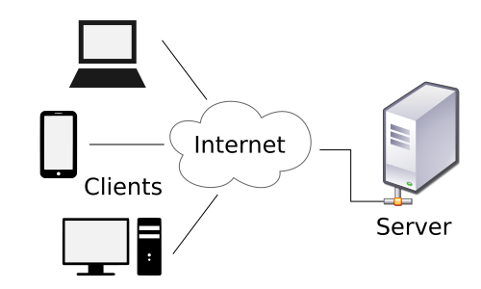

2)- To become a Web Developer, you should have **an understanding of HTML, CSS, and JavaScript** .

It's also recommended to learn about CSS and CSS frameworks. Developing these fundamental web development skills will give you the foundation and logic for communicating with programming languages.

3)- A web developer's job is **to create websites** .

While their primary role is to ensure the website is visually appealing and easy to navigate, many web developers are also responsible for the website's performance and capacity.